import warnings  
import glob  
warnings.filterwarnings("ignore")  
from nilearn import plotting  
from nilearn.image import load_img, coord_transform  
import matplotlib.pyplot as plt  
import numpy as np  
%matplotlib inline

def display_py_mat(mat_file, py_file, threshold=0, c_coords=(0, 0, 0)):  
 fig, axes = plt.subplots(nrows=2, ncols=1, figsize=(11.5, 7))  
 plotting.plot_stat_map(mat_file,   
 threshold=threshold, cut_coords=c_coords, display_mode='ortho',  
 cmap=plt.cm.hsv, vmax=0.5, symmetric_cbar=False, axes=axes[0],  
 title='MATLAB Generated')  
 plotting.plot_stat_map(py_file,   
 threshold=threshold, cut_coords=c_coords, display_mode='ortho',  
 cmap=plt.cm.hsv, vmax=0.5, symmetric_cbar=False, axes=axes[1],  
 title='Python Generated')  
 plt.tight_layout()  
 plt.show()

files = sorted(glob.glob('*.nii'))

# PCC

## Rest, FC

display_py_mat(files[0], files[8], threshold=0.2, c_coords=(0, -66, 39))

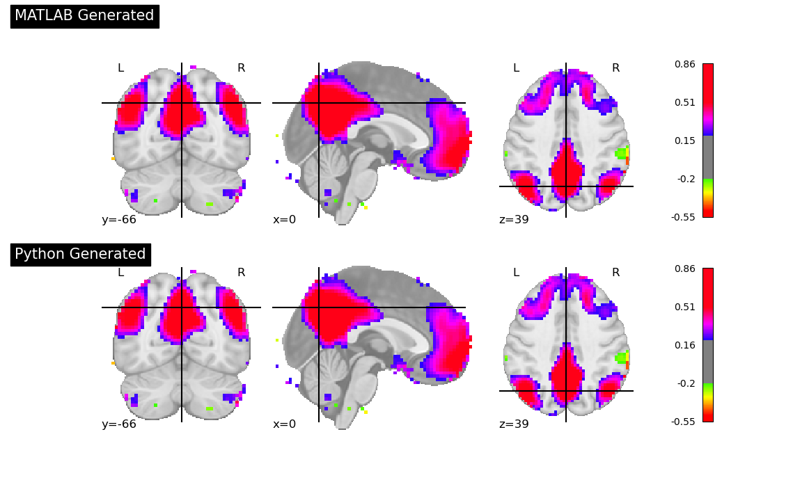

## Rest, ISFC

display_py_mat(files[1], files[9], threshold=0.2, c_coords=(0, -66, 39))

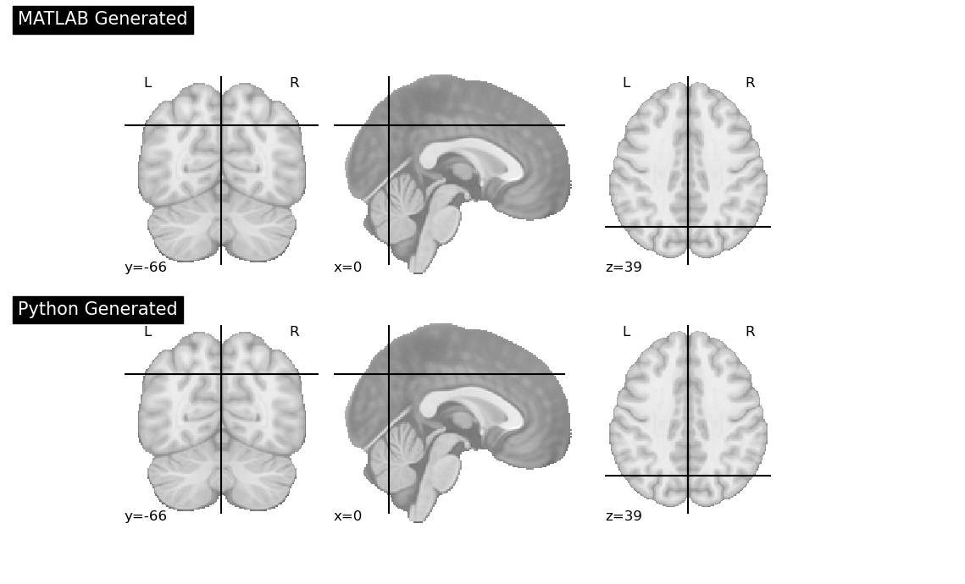

## Task, FC

display_py_mat(files[2], files[10], threshold=0.2, c_coords=(0, -66, 39))

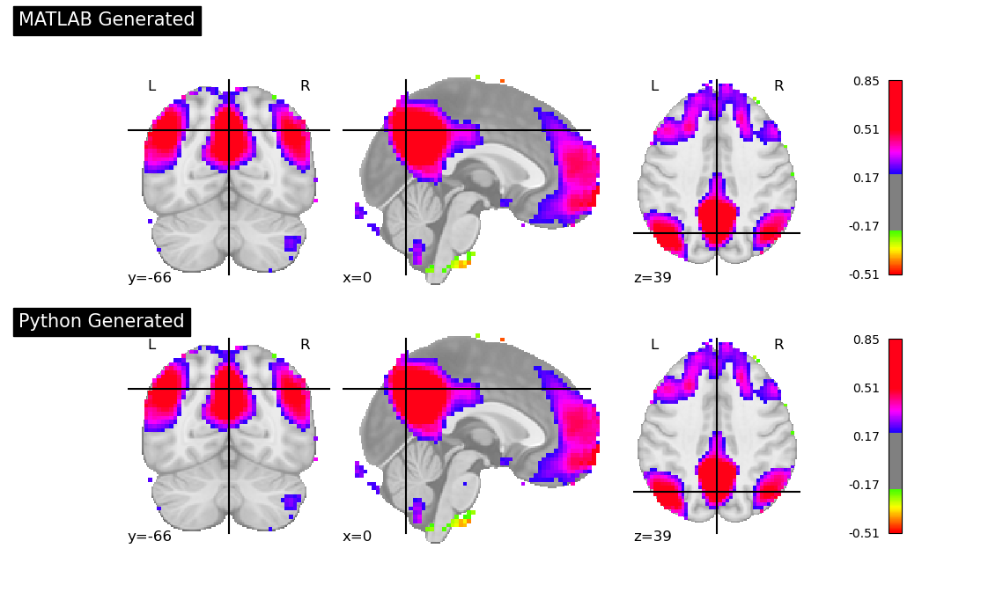

## Task, ISFC

display_py_mat(files[3], files[11], threshold=0.2, c_coords=(0, -66, 39))

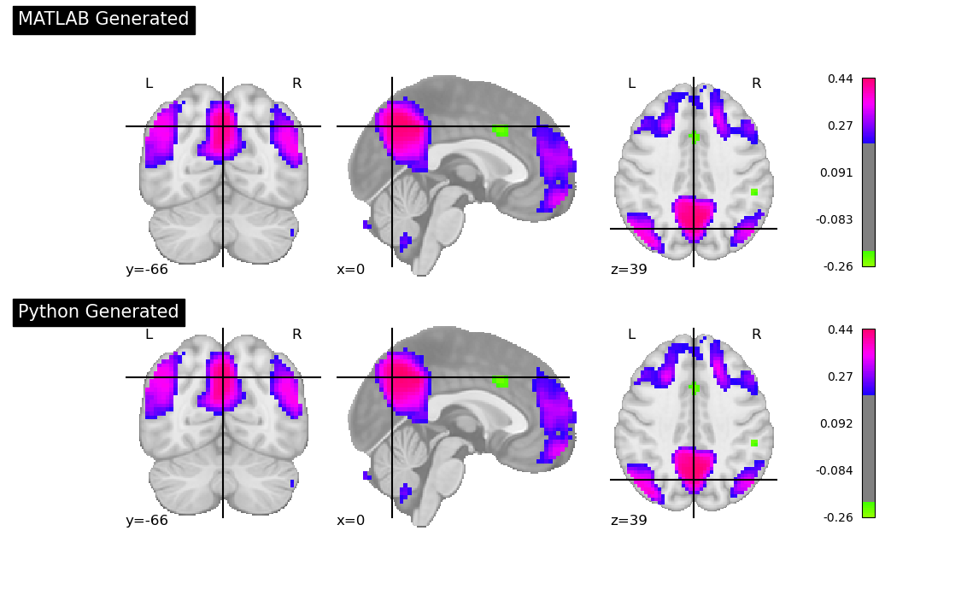

# Auditory Network

## ROI=1 (A1_R), FC

display_py_mat(files[4], files[12], threshold=0.3, c_coords=(6, -18, 15))

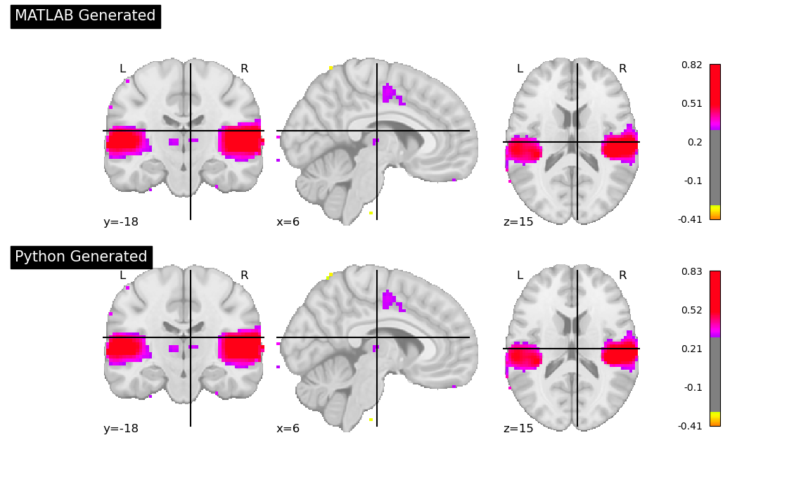

## ROI=1 (A1_R), ISFC

display_py_mat(files[5], files[13], threshold=0.1, c_coords=(6, -18, 15))

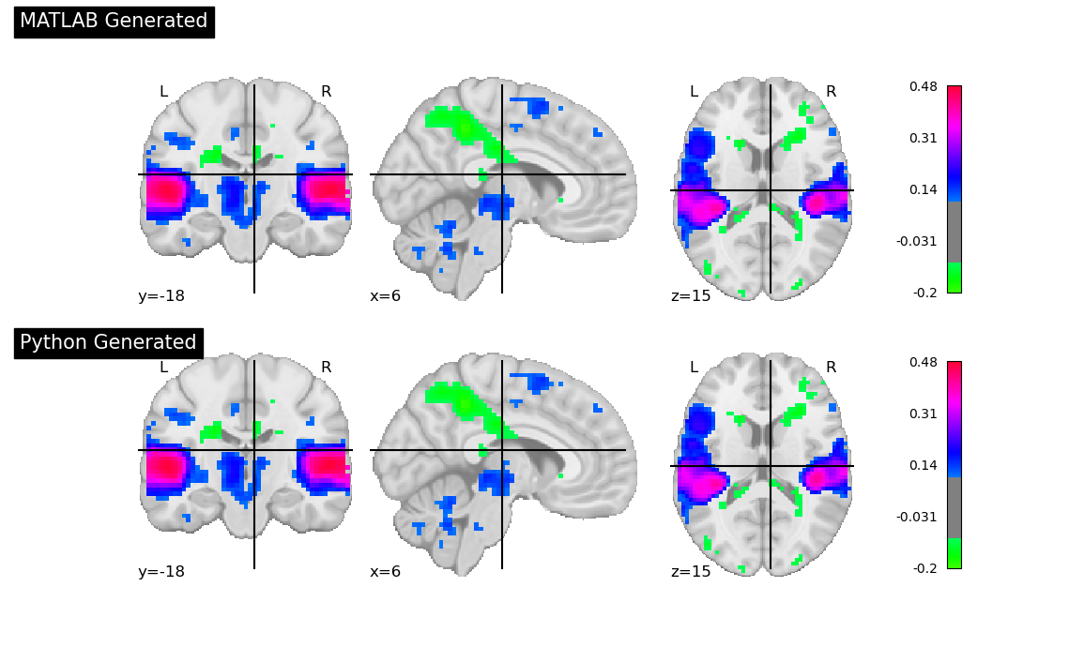

### ROI=5 (A1_L), FC

display_py_mat(files[6], files[14], threshold=0.3, c_coords=(-33, -30, 15))

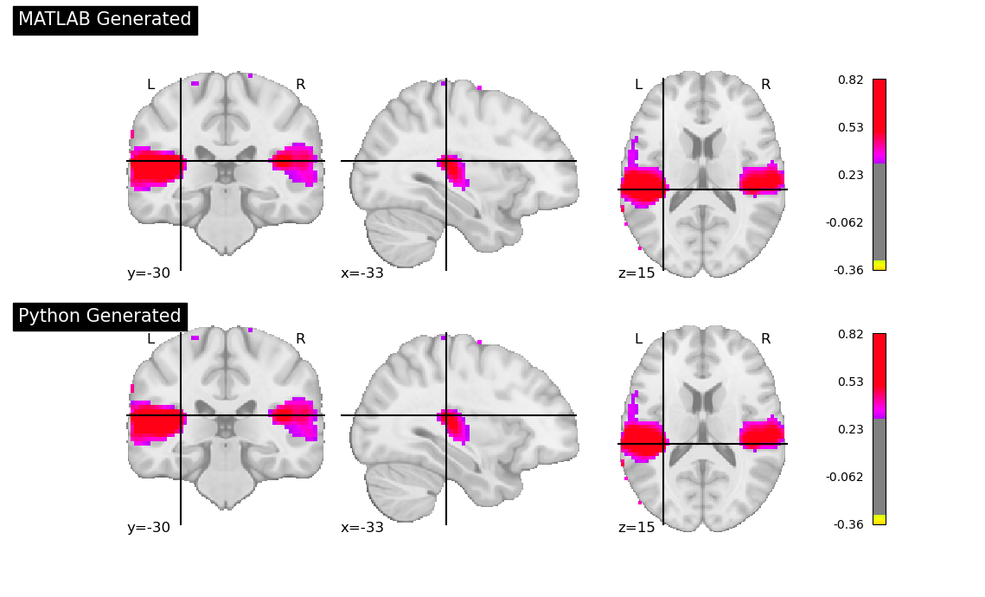

### ROI=5 (A1_L), ISFC

display_py_mat(files[7], files[15], threshold=0.1, c_coords=(-33, -30, 15))

